[MathWorks](http://www.mathworks.com/)

Thank you for your interest in the Web Producer / Front-End Web Developer position at MathWorks.

We recommend spending an **hour and a half** to create a page as close to the following as possible. Please focus on the top half of the page (the navigation, the large banner area, the “Explore what others have done with MATLAB” section and country/state popup) if you are running out of time.   
  
Desktop View (desktop_view.jpg)

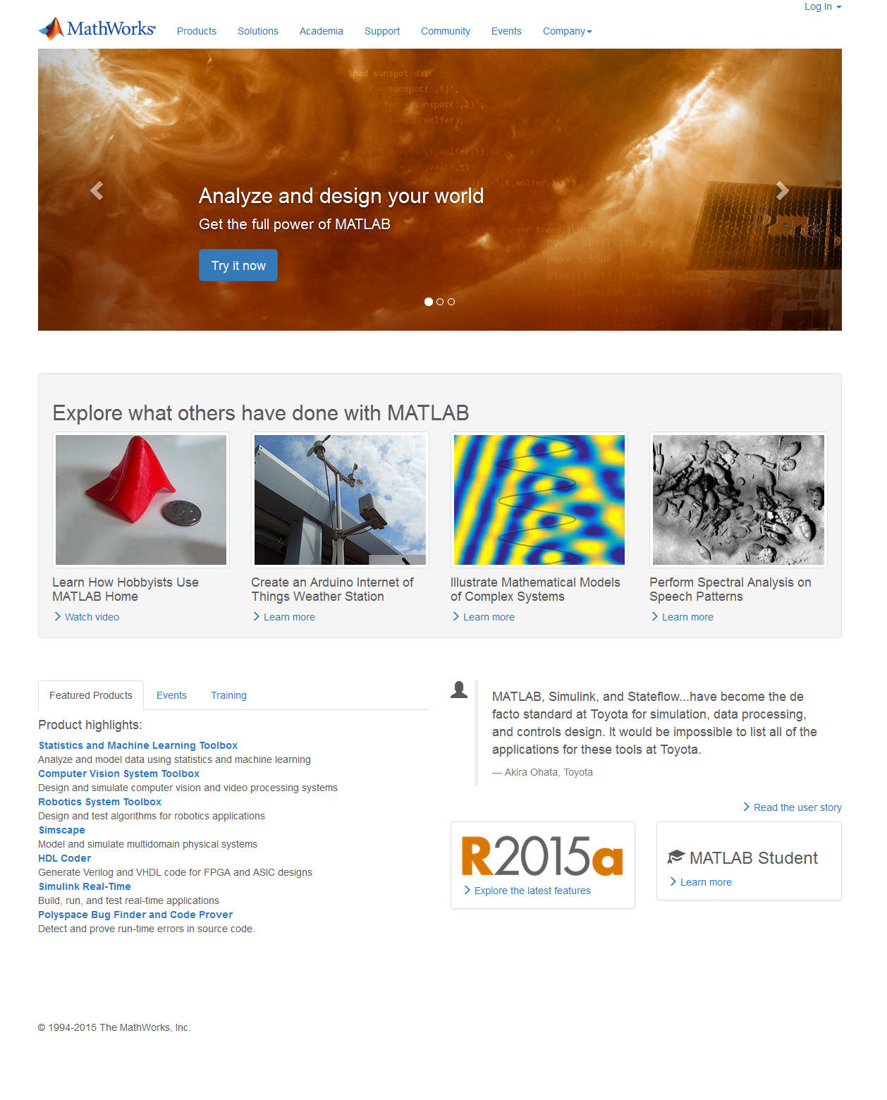

Mobile View – less than 768px (mobile_view.jpg)  
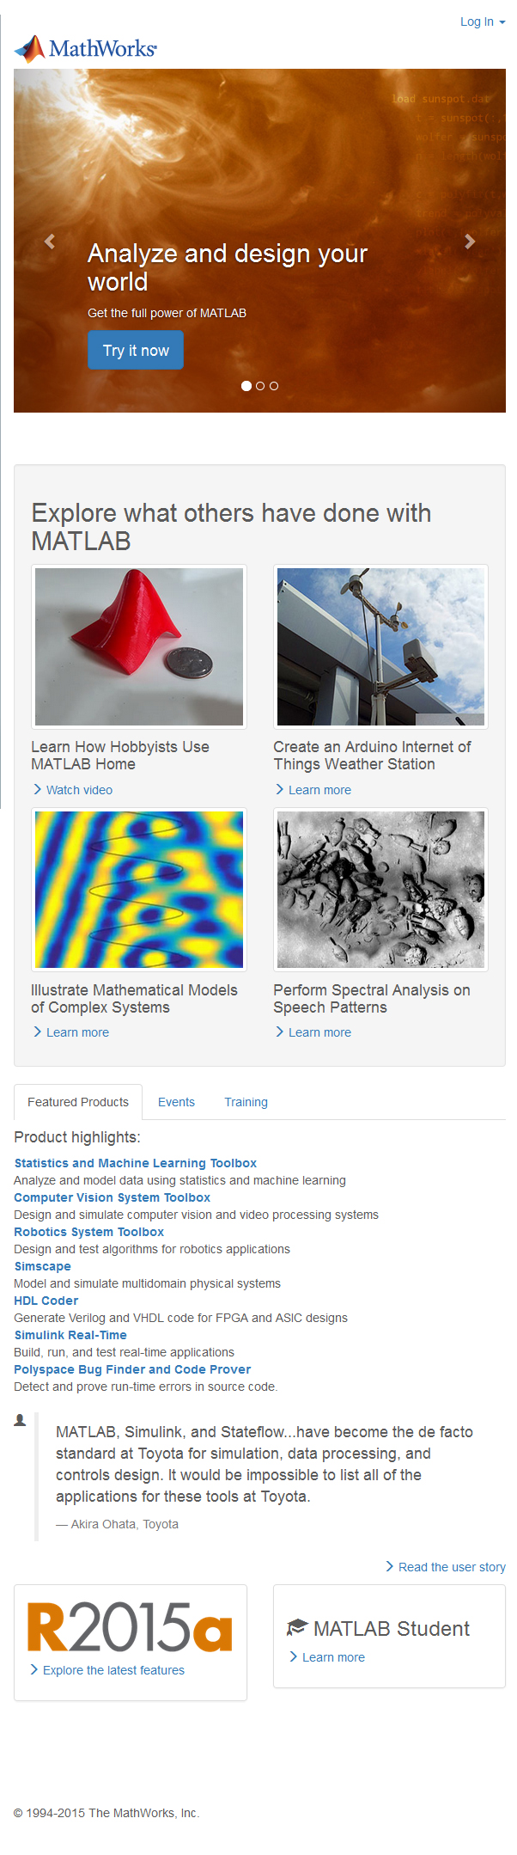

The page (index.html) has been setup using the Bootstrap framework. If you would like to use another framework to build this page, you can proceed to use what you are most comfortable with. If you choose to use Bootstrap and you are not familiar with it, take as much time as you need to familiarize yourself with it. The screenshot shown uses the Bootstrap styling, if you use another framework, you do not need to match the exact styling of the page.

A custom.css has been provided, feel free to use any classes within the file.   
  
**Specific functionality on the page to build:**

1. There are two dropdowns on the page.
   1. The last item of the navigation should contain a dropdown with the following values:
      1. About MathWorks
      2. Founders
      3. Careers
      4. Social Mission
      5. Newsroom
      6. Contact Us
      7. Directions
   2. Log In should contain two values:
      1. Login In
      2. Create Account
2. The next section with the large banner should contain 3 rotating features. User can click on the left / right arrow and also the dots to view the other features.
   1. Feature 1: Analyze and design your world  
      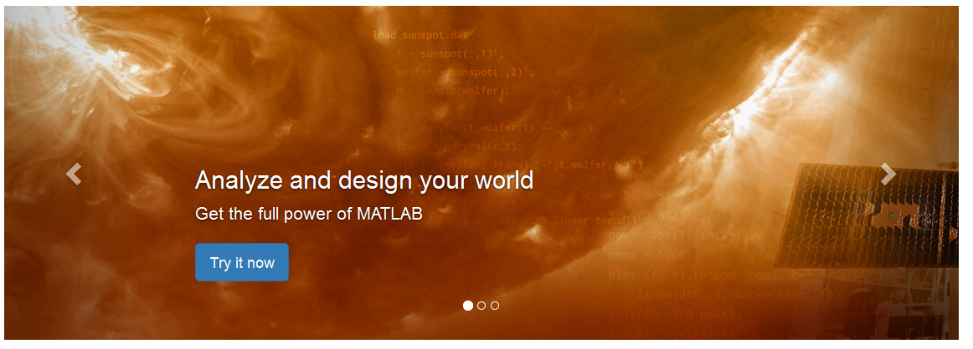
   2. Feature 2: Explore what others have done  
      
   3. Feature 3: Latest Release  
      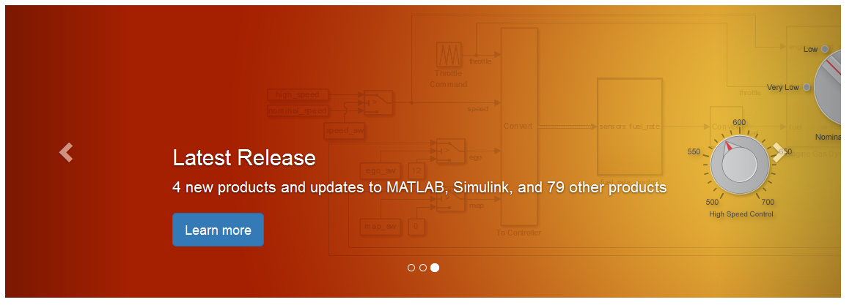
3. User can click Events and Training and content for the respective section would appear beneath it.
4. When the page initially loads, show a popup for the user to select the country. It should look like this:

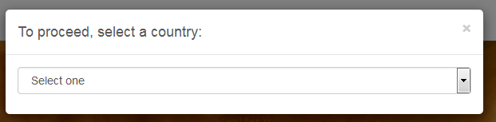  
  
Upon selection of “United States”, it should look like:  
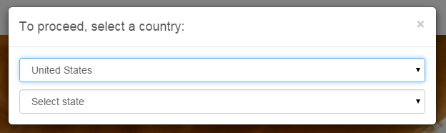

* For the purposes of this test, there are only two selections “United States” and “Canada”. Upon selection of “United States”, show another drop-down list containing the list of states. Upon selection of “Canada” or a state, close the popup.

If you have any questions, please email Ryan.Tremblay@mathworks.com.